Körber releases new cloud-native PAS-X Track & Trace to strengthen serialization compliance and system efficiency with comprehensive lifecycle management

Lüneburg, Germany, 4 March 2025. Körber has launched the latest version of its PAS-X Track & Trace solution, designed to minimize total cost of ownership (TCO) and enhance efficiency through comprehensive lifecycle management and seamless, vendor-agnostic system integration. As the industry evolves rapidly, this advanced solution meets the increasing demand for robust automation, process stability, and flexible connectivity – without restricting companies to a single technology stack.

Pharmaceutical and biotech companies must comply with various market-specific anti-counterfeiting requirements, such as GS1 standards, Russian crypto codes, Chinese NMPA, FDA, EMA, and more. They need to globally serialize their products and manage the associated complexities. New packaging lines and legislative changes must be incorporated flexibly. Security gaps shorten the support cycles of IT systems and present a challenge to keep the system up to date and validated with minimal effort.

PAS-X Track & Trace V3 addresses these challenges, featuring advanced technology with automatic scaling, optimized deployment procedures, and centralized system operation. Its cloud-based design allows it to run on-premise, in the customer's cloud, or fully managed by Körber as Software as a Service (SaaS), fitting into any company's business strategy. Körber provides continuous support to keep the system up-to-date, along with an optimized validation approach that significantly reduces customer efforts for revalidation.

“PAS-X Track & Trace ensures compliance with regulatory standards while boosting operational efficiency. The latest version is a lean, functional complete and cloud-native solution designed to simplify daily operations and enable digital transformation as part of broader company strategies. Customers benefit from reduced total cost of ownership (TCO), comprehensive lifecycle management, and a future-proof software solution that aligns with their long-term IT strategy,” says René Reuter, Product Owner Software at Körber Business Area Pharma.

The serialization solution serves as a vendor-agnostic site manager and harmonization layer between site and enterprise systems, seamlessly integrating packaging lines, MES and ERP systems, as well as serial number repositories from any vendor through standardized and configurable interfaces. It can be quickly implemented with reduced qualification requirements due to its configurable integration into existing business processes and fully qualified out-of-the-box standard product design.

Picture
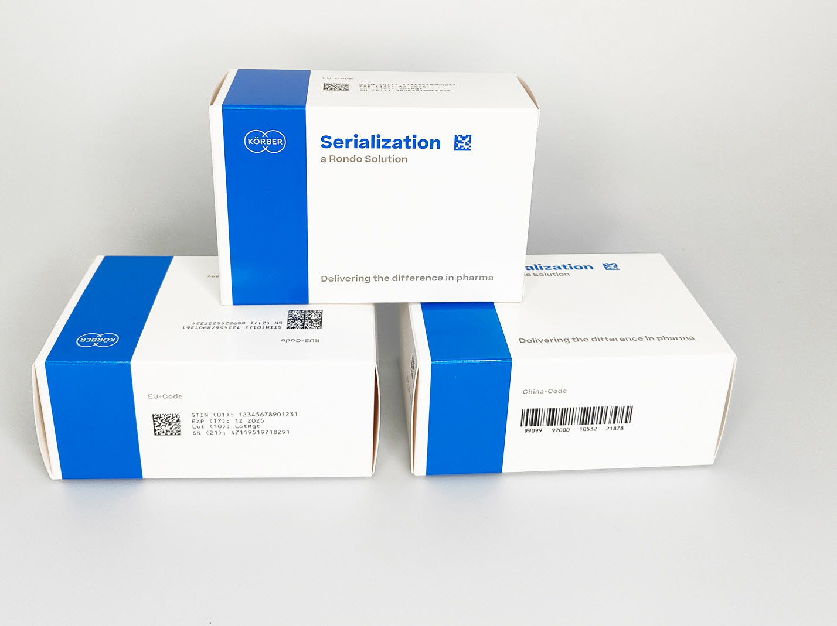

About Körber
We are Körber – an international technology group with around 13,000 employees at over 100 locations worldwide and a common goal: We turn entrepreneurial thinking into customer success and shape the technological change. In the Business Areas Digital, Pharma, Supply Chain, and Technologies, we offer products, solutions and services that inspire. We act fast to customer needs, we execute ideas seamlessly, and with our innovations we create added value for our customers. In doing so, we are increasingly building on ecosystems that solve the challenges of today and tomorrow. Körber AG is the holding company of the Körber Group.

At the Körber Business Area Pharma we are delivering the difference along the pharma value chain with our unique portfolio of integrated solutions. With our software solutions we help drug manufacturers to digitize their pharmaceutical, biotech and cell & gene therapy production. The Werum PAS-X MES Suite is recognized as the world’s leading Manufacturing Execution System for pharma, biotech and cell & gene. Our Werum PAS-X Savvy Suite accelerates product commercialization with data analytics and AI solutions and uncovers hidden business value.

www.koerber-pharma.com

Contact
Dirk Ebbecke
Körber Business Area Pharma
Head of Product Marketing
T: +49 4131 8900-0
E-mail: dirk.ebbecke@koerber.com

