Werum IT Solutions wins
“Best Bioprocessing Software Award 2019”
News Release

News Release

Werum’s PAS-X MES recognized as “Best Bioprocessing Software” at this year’s Asia-Pacific Bioprocessing Excellence Awards in Singapore
Lüneburg/Germany, Bangkok/Thailand, 11 March 2019 – Werum IT Solutions, global leading supplier of manufacturing execution systems (MES) for pharma and biotech, wins the “Best Bioprocessing Supplier Award: Software” for its out-of-the-box PAS-X MES software product. PAS-X is widely recognized in the industry for being a highly standardized, flexible and powerful solution that is adopted by the majority of the world’s top 30 pharmaceutical and biotech manufacturers to help improve productivity, safeguard regulatory compliance and fulfill the process requirements of these industries.

“Biotech is a highly important industry segment for Werum”, said David Margetts, Managing Director, Werum IT Solutions Ltd., Thailand, at the award ceremony in Singapore. “Our PAS-X product is proven as the leading Electronic Batch Recording solution on the market. It is powering the paperless production of innovative medicines at plants across the globe with a complete and easy integration to the typical ERP, LIMS, DCS and smart devices found in bioprocessing. The complex processes required in biopharmaceuticals and cell & gene therapy are supported by PAS-X as a standard which means our clients gain the great benefits and value of digital processes with built-in compliance.
In Asia, our teams are highly experienced in supporting both regional and global biotech manufactures for many years to improve efficiency and quality using PAS-X MES. I would like to thank all of our customers, partners and employees for their continued support, trust and commitment. Such recognition encourages Werum to further advance our team’s strength and product portfolio to lead the digitization of the pharma and biotech industry.”

The award ceremony was held in conjunction with the 6th Annual Biologics Manufacturing Asia exhibition and seminar in Singapore celebrating outstanding bioprocessing organizations, technologies and individuals that contributed to achieving excellence in the biotech and pharma industries. At the ceremony more than 100 bioprocessing VIPs from over 9 different regional biologics hubs across Asia-Pacific came together to celebrate their peers’ success.

Photos:
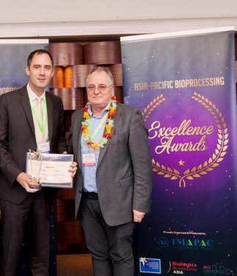

David Margetts (left), Managing Director, Werum IT Solutions Ltd., Thailand, receiving the award

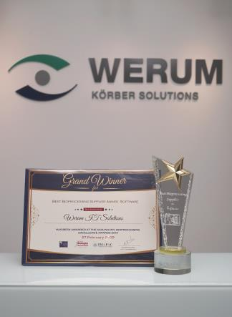
Werum’s PAS-X MES software named as “Best Bioprocessing Software”

About Werum IT Solutions
Werum IT Solutions is the world’s leading supplier of manufacturing execution systems (MES) and manufacturing IT solutions for the pharmaceutical and biopharmaceutical industries. Its PAS-X software product is run by the majority of the world’s top 30 pharmaceutical and biotech companies and also by many mid-sized manufacturers. Werum’s manufacturing IT solutions help pharma manufacturers to increase efficiency, improve productivity, and meet regulatory requirements. Founded in 1969, Werum is headquartered in Lüneburg, Germany, and has many locations in Europe, America, and Asia.
www.werum.com

Werum is part of Medipak Systems, the Pharma Systems business area of the international technology group Körber. The Business Area’s companies, Dividella, Fargo Automation, Mediseal, Rondo, Seidenader Maschinenbau, Systec & Services, Traxeed and Werum IT Solutions, are global leading providers of high-quality solutions for the manufacturing and packaging process of pharmaceutical products. As a Medipak Systems company, Werum provides integrated IT solutions for all phases of pharmaceutical and biopharmaceutical production – including process development, commercial production, and packaging as well as track & trace serialization. Körber unites around 12,000 professionals in industry-leading companies worldwide, achieving annual earnings of 2.6 billion Euros.
www.medipak-systems.com, www.koerber.com

Contact:
Dirk Ebbecke
Director Corporate Communications
Werum IT Solutions GmbH
Wulf-Werum-Str. 3
21337 Lüneburg, Germany
Tel. +49 4131 8900-689
Fax +49 4131 8900-200
dirk.ebbecke@werum.com

