Körber wins Europe Bioprocessing Excellence Award
for its Werum PAS-X software products

Lüneburg, Germany, 28 October 2021. Körber, provider of the world’s leading Manufacturing Execution System (MES) for the pharma, biotech and cell & gene therapy industries, is honored for its Werum PAS-X software products with the Europe Bioprocessing Excellence Award 2021 in the category “Best Bioprocessing Supplier Award: Software”.

The award recognizes Körber as industry leader and trend-setter in the bioprocessing scene, facilitating biomanufacturing excellence at enhanced speed, reduced cost and superior quality all across Europe and the rest of the world.

Körber received the Europe Bioprocessing Excellence Award for its Werum PAS-X MES Suite, which is recognized as the world’s leading Manufacturing Execution System for the pharma, biotech and cell & gene industries. While the number of cell therapy products in late stages of clinical trials is rapidly growing, electronic systems are emerging as the only option for managing large patient volumes. Through digitized and automated processes, PAS-X MES is ideally suited to target these challenges for cell & gene therapy manufacturers.

Werum PAS-X MES is supplemented by innovative data science software: Werum PAS-X Savvy helps to accelerate biopharmaceutical processes and connects people across departments and sites. With PAS-X Savvy bioprocess engineers and data scientists can manage, visualize and analyze bioprocess data fast, comprehensive and in real time.

“We are truly honored to receive this high industry recognition and to be named Best Bioprocessing Supplier for software,” says Dr. Christoph Fink, Chief Operating Officer (COO) Software at the Körber Business Area Pharma. “I would like to thank our customers and partners for their trust in us and our digital solutions. This award underlines that we truly understand what it takes to ensure manufacturing quality in scaling highly complex and variable manufacturing processes – e.g. in biotech and cell & gene. This motivates us to constantly improve the features of our products, share best practices and advisory in the growing community of our clients.”

The award ceremony was held virtually in conjunction with the Biologics Contract Manufacturing Europe 2021 and 4th Biologics World Nordic 2021 conferences with more than 500 representatives from Europe’s top biopharma and contract manufacturing organizations.

Photo
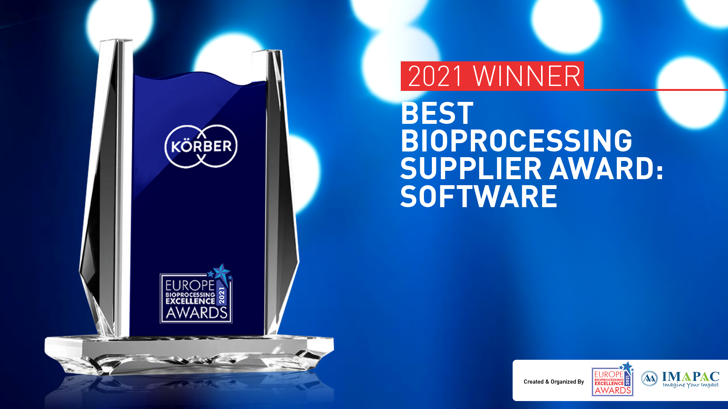

About Körber
Körber is an international technology group with about 10,000 employees, more than 100 locations worldwide and a common goal: We turn entrepreneurial thinking into customer success and shape the technological change. In the Business Areas Digital, Pharma, Supply Chain, Tissue and Tobacco, we offer products, solutions and services that inspire.
At the Körber Business Area Pharma we are delivering the difference along the pharma value chain with our unique portfolio of integrated solutions. With our software solutions we help drug manufacturers to digitize their pharmaceutical, biotech and cell & gene factories. The Werum PAS-X MES Suite is recognized as the world’s leading Manufacturing Execution System for pharma, biotech and cell & gene. Our Werum PAS-X Intelligence Suite accelerates product commercialization with data analytics and AI solutions and uncovers hidden business value.
www.koerber-pharma.com

Contact
Dirk Ebbecke
Körber Business Area Pharma
Head of Global Marketing & Communications Software
T: +49 4131 8900-0
E-mail: dirk.ebbecke@koerber.com

