Körber wins Asia-Pacific Bioprocessing Excellence Awards for its Werum PAS-X MES software

Lüneburg, Germany / Bangkok, Thailand, 19 March 2021. Körber, provider of the world’s leading Manufacturing Execution System (MES) for the pharma, biotech and cell & gene therapy industries, was honored for its Werum PAS-X in two different categories at the 8th Annual Biologics Manufacturing Asia 2021 conference, held virtually from 16-17 March 2021: “Best Digital Solution for Cell & Gene Therapy” and “Best Bioprocessing Supplier – Software”.

The software experts of Körber Business Area Pharma received the award for their market-leading MES “Werum PAS-X”, which is ideally suited to tackle the key challenges for cell & gene therapy manufacturers, managing their complex processes and controlling the chain of identity. Moreover, PAS-X supports pharma and biotech manufacturers to gain operational excellence by increasing efficiency, improving productivity and meeting regulatory requirements – factors that are all essential for a company's performance in these highly regulated industries.

“We are truly honored to receive these high recognitions and to be named ‘Best Bioprocessing Supplier Award – Software’ for the third consecutive year,” states Teerapong Cheepchol, President Software Asia at Körber Business Area Pharma. “I would like to thank our customers for their trust in us and our digital solutions! This motivates us to keep doing our best to cater to pharma and biotech manufacturers worldwide and develop the best digital solutions and services. Therefore, we are committed to support our growing customer base in Asia and globally and provide you with highest level of quality in our PAS-X products and services in order to ensure our fullest support to the industry and you as our customers to bringing value for people’s lives.”

The award ceremony was held in conjunction with the 8th Annual Biologics Manufacturing Asia and the 5th annual Biologistics World Asia 2021 with more than 1,000 representatives from Asia’s top biologic manufacturers under one virtual roof.

Photo
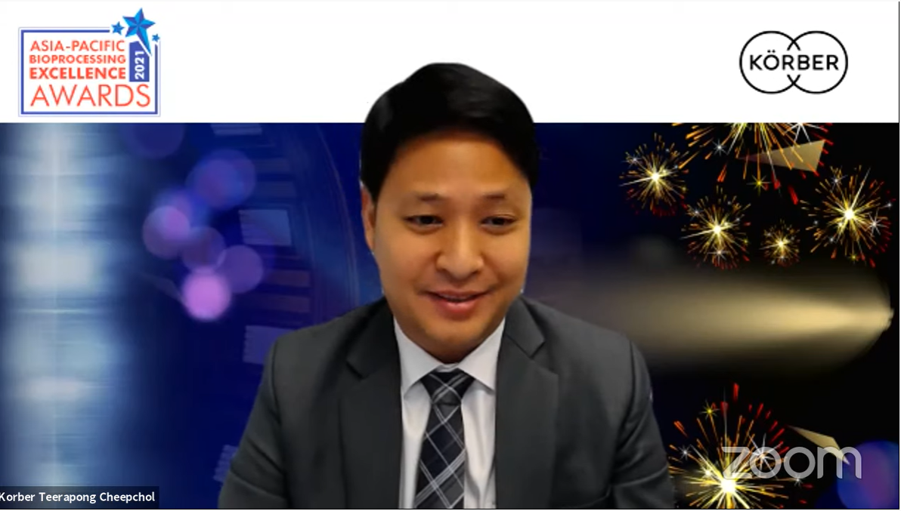
Teerapong Cheepchol, President Software Asia, Körber Business Area Pharma, receives the award for the third consecutive year during a virtual award ceremony.

About Körber
The Körber Group is an international technology group with around 10,000 employees at more than 100 locations worldwide, all bound by the same common goal: By uniting under a single brand, // Working in partnership, we are driven by an entrepreneurial spirit to turn our collective expertise into value for our customers. In the Business Areas Digital, Pharma, Supply Chain, Tissue and Tobacco, we offer products, solutions and services that inspire.
Our Business Area Pharma offers a portfolio of integrated services that provides our customers with a decisive competitive advantage along the entire value chain of pharmaceutical product development. Our software solutions support pharmaceutical enterprises with the digitization of their pharma-, biotech-, cell and gene therapy manufacturing processes. Werum's PAS-X is the market-leading MES (manufacturing execution system) for the pharmaceutical and biopharmaceutical industries. Our data analysis and AI solutions help accelerate the commercialization of new products and uncover the hidden values of company data.
www.koerber-pharma.com

Contact:
Dirk Ebbecke
Körber Business Area Pharma
Head of Global Marketing & Communications Software
Werum IT Solutions GmbH
Phone: +49 4131 8900-0
E-mail: dirk.ebbecke@koerber-pharma.com

