MES implementation support in France:
SPC Consultants certified as new “PAS-X Endorsed Service Partner Local”
News Release

Werum IT Solutions and French-based SPC Consultants signed a partnership agreement / Pharma and biotech manufactures benefit from MES support in France, Belgium and Switzerland
Lyon, France, 18 December 2018 – Another promising partnership has been brought on its way for pharma and biotech manufacturers in France, Belgium and Switzerland using Werum’s PAS-X MES to optimize their manufacturing. To further expand the PAS-X Service Partner network of Werum IT Solutions, the world’s leading supplier of Manufacturing Execution Systems (MES) for Pharma & Biotech and the French-based company SPC Consultants signed a mutual agreement to offer extensive MBR services.

SPC Consultants is specialized in supporting French pharma and biotech manufacturers in project management, validation of computerized systems and their maintenance. As a PAS-X Endorsed Service Partner, SPC Consultants will provide support to Werum customers in France, Belgium and Switzerland in the field of MBR design, support and verification. The partnership will be extended mid-term to additional activities.

“With the increase of our business on the French market we extend our local services capacity accordingly. The partnership with SPC Consultants gives us this opportunity. They are already well-known by our customers and recognized for their high quality of work. I’m convinced that this is a win-win-win situation for our pharma and biotech customers, for SPC Consultants and for Werum IT Solutions”, says Marc Meyer, Managing Director at Werum IT Solutions France.

Thierry Lacombe, CEO of the SPC Group, adds: “As independent player of the MES market in France, SPC Group is eager to collaborate with the main MES vendors. Our strong and historical positioning within the pharmaceutical sector has naturally led us to build a non-exclusive partnership with Werum IT Solutions, whose solution is clearly a reference for the sector.”

PAS-X Endorsed Service Partners meet all requirements of Werum's PAS-X Service Partner Program. The main objective is to offer the same quality and competence of services to Werum customers all over the world – through reliable, experienced and certified partners. The Service Partners need to have comprehensive PAS-X knowledge, participate at PAS-X trainings on a regular basis, possess experience in the regulated industry and use a quality management system. The certification has to be renewed on a regular basis.

Picture
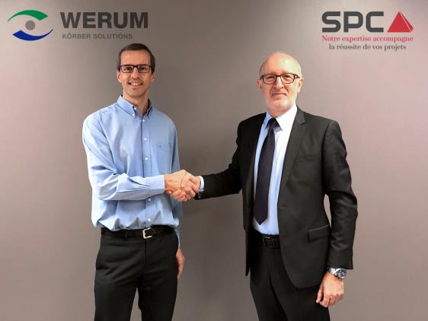
Closing the agreement (from left): Marc Meyer, Managing Director at Werum IT Solutions France, and Thierry Lacombe, CEO of the SPC Group

About Werum IT Solutions
Werum IT Solutions is the world’s leading supplier of manufacturing execution systems (MES) and manufacturing IT solutions for the pharmaceutical and biopharmaceutical industries. Its PAS-X software product is run by the majority of the world’s top 30 pharmaceutical and biotech companies and also by many mid-sized manufacturers. Werum’s manufacturing IT solutions help pharma manufacturers to increase efficiency, improve productivity, and meet regulatory requirements. Founded in 1969, Werum is headquartered in Lüneburg, Germany, and has many locations in Europe, America, and Asia.
www.werum.com

Werum is part of Medipak Systems, the Pharma Systems business area of the international technology group Körber. The Business Area’s companies, Dividella, Fargo Automation, Mediseal, Rondo, Seidenader Maschinenbau, Systec & Services, Traxeed and Werum IT Solutions, are global leading providers of high-quality solutions for the manufacturing and packaging process of pharmaceutical products. As a Medipak Systems company, Werum provides integrated IT solutions for all phases of pharmaceutical and biopharmaceutical production – including process development, commercial production, and packaging as well as track & trace serialization. Körber unites around 12,000 professionals in industry-leading companies worldwide, achieving annual earnings of 2.6 billion Euros.
www.medipak-systems.com, www.koerber.com

Contact:
Dirk Ebbecke
Director Corporate Communications
Werum IT Solutions GmbH
Wulf-Werum-Str. 3
21337 Lüneburg, Germany
Tel. +49 4131 8900-689
Fax +49 4131 8900-200
dirk.ebbecke@werum.com

About SPC Consultants
SPC Consultants is part of the SPC group and based in the French metropolis of Lyon. It has been founded in 1988 and is the biggest entity of the group. SPC Consultants is a consulting and engineering company specializing in the field of Industrial Information Systems. For the last 30 years, it has been supporting major pharmaceutical companies in the various phases of their computerization and digital transformation projects. Its engineering offer covers the management and implementation of computerized or automated solutions, the validation of these applications and their maintenance. The group’s contribution of value addresses three areas of expertise: process control & safety, production information systems, information systems dedicated to laboratories & quality. Their staff is highly recognized for their dual skills – meeting IT/automation requirements as well as business/process ones.
www.groupe-spc.com

