**Körber and AspenTech partner to accelerate the digital transformation of clients using PAS-X MES and Aspentech Inmation**

**Lüneburg, Germany, 24 October 2024. Körber has formally certified AspenTech Inmation™ as a “PAS-X MSI Plug & Produce” partner at the “ready” level, marking a pivotal advancement for customers seeking seamless shop floor integration combined with sophisticated data management. This partnership delivers enhanced operational efficiency and smarter decision-making for manufacturers across the pharmaceutical, biopharmaceutical, and cell & gene therapy sectors.**

By providing seamless integration of Körber’s PAS-X Manufacturing Execution System (MES) with AspenTech Inmation’s centralized Industrial Data Fabric customers can expedite the implementation of a manufacturing IT/OT architecture allowing full digitalization for maximum visibility and agility in manufacturing operations management.

As pharma and biotech manufacturers are going paperless in their production operations these days, they not only strive to digitalize the batch record but aim to integrate the manufacturing shop floor systems via interfaces into the MES from day one. Suppliers need to be prepared by offering agreed standard interfaces between systems to enable a swift and robust implementation. Körber and AspenTech have agreed on the PAS-X MSI Plug & Produce interface for this purpose and are ready to go with a standard out-of-the-box solution for the integration of PAS-X MES with AspenTech Inmation – on-premise as well as in the cloud. In projects the systems become interoperable a lot faster, and customers do not need to worry about a solid data and communication foundation anymore. Instead, they can focus on improving compliance and performance of their manufacturing operations by dashboarding, data analysis and even AI-driven use cases. Körber and AspenTech have already implemented this integrated solution with several customers.

Commenting on the longstanding collaboration with a functioning MSI interface in operation at various customers since 2020, Nina Schwalb, VP Inmation Industrial Data Fabric and Data Strategy at AspenTech, stated, “Achieving the status of a certified ‘PAS-X MSI Plug & Produce’ partner is a major milestone for AspenTech Inmation.”

“We are delighted to foster our collaboration with AspenTech Inmation and to give this further emphasis under the umbrella of our Körber PAS-X MSI Partner Ecosystem,” added Lars Hornung, Senior Principal Alliances & Technology Partner Software at Körber Business Area Pharma. “Industry organizations like ISPE highlight the importance of integrating MES, Historians, and equipment as the future of advanced manufacturing. Through this partnership, Körber and AspenTech Inmation are leading this industry evolution, enabling manufacturers to manage exceptions more effectively, ensure long-term compliance, and continuously enhance production outcomes while safeguarding data integrity.”

**Picture**

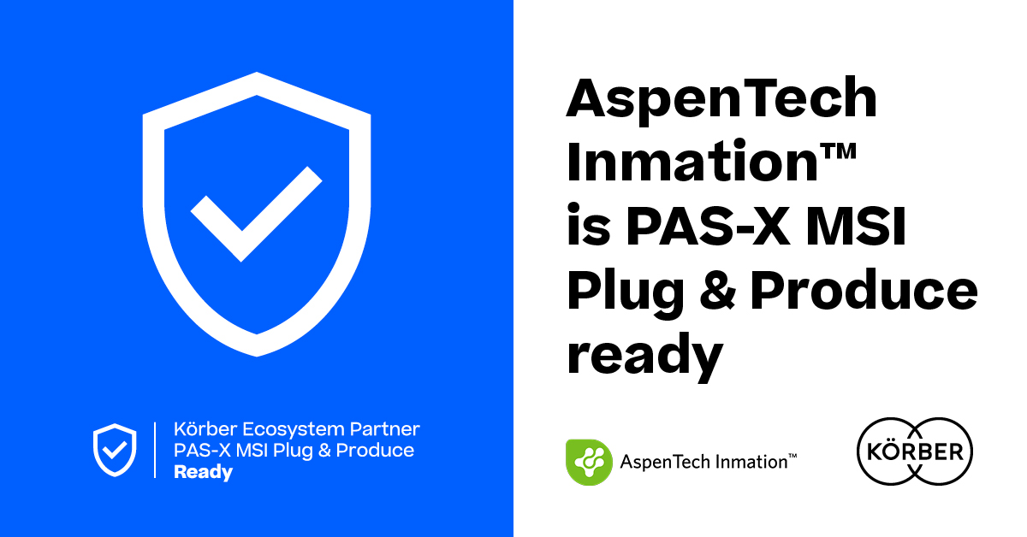

**About AspenTech**

Aspen Technology, Inc. (NASDAQ: AZPN) is a world leader in providing technology to support asset optimization in a range of industries. The portfolio of Aspen solutions has grown from flowsheet simulators to supporting the Artificial Intelligence (AI) and Machine Learning (ML) technologies of the future.

**About AspenTech Inmation**

AspenTech Inmation Data Fabric is an industrial software specialized in industrial data automation and industrial data management. The product is designed to help companies manage and analyze their data more effectively and at scale, allowing them to make better decisions and optimize their operations.

The AspenTech Inmation Data Fabric offers a range of features and capabilities, including data acquisition, contextualization, storage, integration, and analytics. The platform can collect data from a variety of sources, including industrial devices (like sensors, PLCs, SCADA systems, and others) as well as non-industrial data sources and data consumers by being native to the modern IT protocols and systems. The data is then stored in a centralized repository, where it can be accessed and analyzed in real time.

AspenTech Inmation Data Fabric can help users identify patterns, trends, and anomalies in their data. This Industrial Data Fabric can be customized to meet the specific needs of different industries, including oil and gas, chemicals, pharmaceuticals, and more.

[www.aspentech.com/en/products/dataworks/aspentech-inmation](http://www.aspentech.com/en/products/dataworks/aspentech-inmation)

**Contact**

Dwaine Plauche / Daniel Secker

Product Marketing Inmation Industrial Data Fabric

E-mail: [dwaine.plauche@aspentech.com](mailto:dwaine.plauche@aspentech.com) / [daniel.secker@aspentech.com](mailto:daniel.secker@aspentech.com)

**About Körber**

We are Körber – an international technology group with more than 12,000 employees at over 100 locations worldwide and a common goal: We turn entrepreneurial thinking into customer success and shape the technological change. In the Business Areas Digital, Pharma, Supply Chain, and Technologies, we offer products, solutions and services that inspire. We act fast to customer needs, we execute ideas seamlessly, and with our innovations we create added value for our customers. In doing so, we are increasingly building on ecosystems that solve the challenges of today and tomorrow. Körber AG is the holding company of the Körber Group.

At the Körber Business Area Pharma we are delivering the difference along the pharma value chain with our unique portfolio of integrated solutions. With our software solutions we help drug manufacturers to digitalize their pharmaceutical, biotech and cell & gene therapy production. The Werum PAS-X MES Suite is recognized as the world’s leading Manufacturing Execution System for pharma, biotech and cell & gene. Our Werum PAS-X Savvy Suite accelerates product commercialization with data analytics and AI solutions and uncovers hidden business value.

[www.koerber-pharma.com](http://www.koerber-pharma.com/)

**Contact**

Dirk Ebbecke

Körber Business Area Pharma

Head of Product Marketing

T: +49 4131 8900-0

E-mail: dirk.ebbecke@koerber.com